Gaman
Cisco Phone Control Gadget

Document history
Date | Person | Version no. | Description
2020-02-25 | Marek Słomiński | 1.0 | First version of the document

Table of Contents
Table of Contents 1
Introduction 2
Gadget Features 3
Contact information 5

Introduction
Cisco Phone Control Gadget has been created to control Agent’s phone directly from Cisco Finesse UI. It optimizes agents’ work because they don’t have to click on Cisco IP phone manually anymore.
Administrator can configure numerous different actions and assign them to buttons visible on top of the Cisco Finesse UI. List of all supported actions depends on the phone model and it is available here.
Basic actions configured by default are as follows:
- Mute
- Volume Down/Up
- Headset
- Speaker

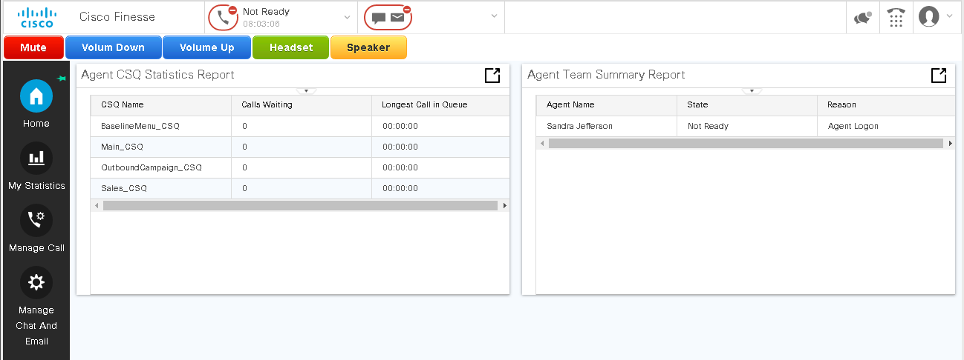

Here is diagram that shows the communication used to execute the commands on the phone.
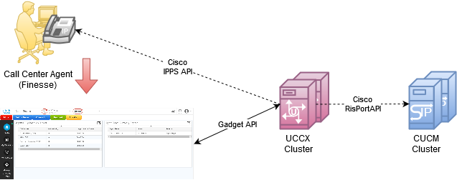
The gadget is designed to work in the existing infrastructure without additional servers. Because gadget is not able to directly communicate to phone and CUCU, UCCX has been used as a proxy HTTP/HTTPS server. We distinguish to basic communication flows in the solution:
- Gadget Initialization flow – triggered when gadget is loading the. In this communication gadget determinates, the phone IP address that the agent is using. In this flow CUCM RisPort API is used.
- Gadget Execution flow – triggered when user clicks on the gadget buttons. In this flow Cisco IP Phone IPPS API is used.

Gadget Features
Cisco Phone Control Gadget allows to send predefined actions to Agent’s phone. UI of the gadget is available on top of the Cisco Finesse Agent application and contains list of buttons. Administrator can configure all buttons and adjust them to the business needs. There can be only one button or numerous buttons (until they fit to the screen). Size of all buttons is configurable (small, regular, large). Each button can have different label, color and action.
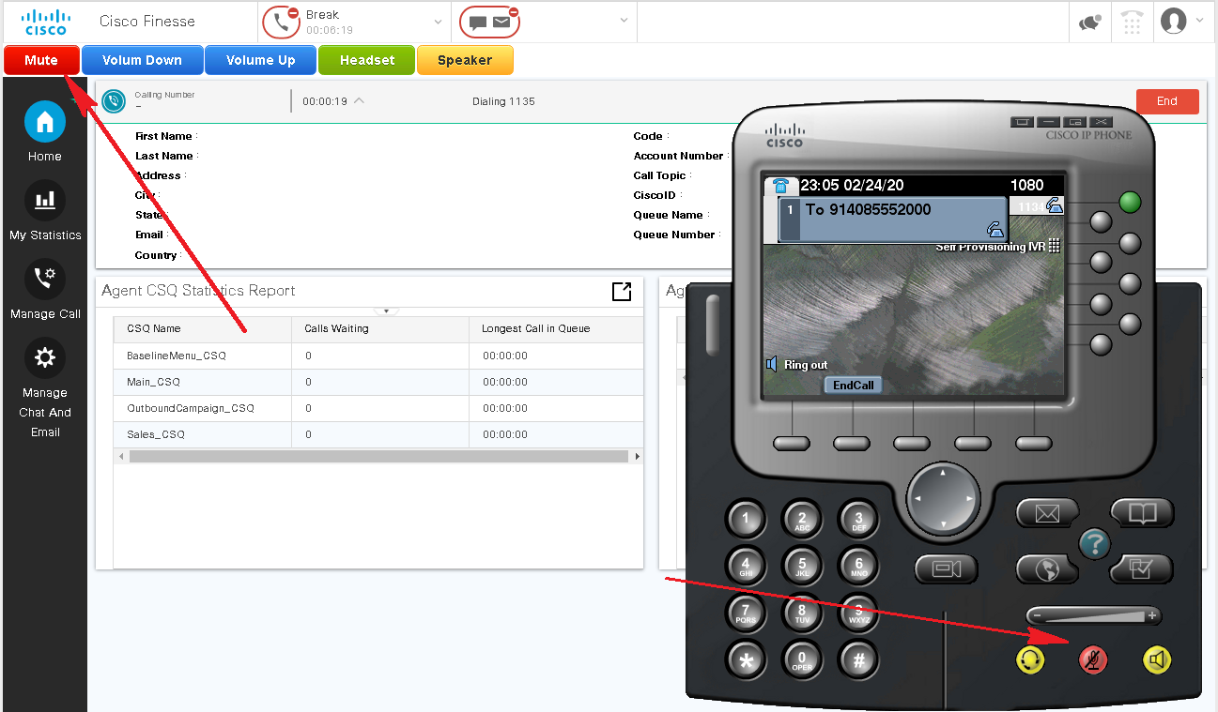
For two actions: Speaker (Key:Speaker) and Headset (Key:Headset) key-pad will be automatically opened once they are clicked.
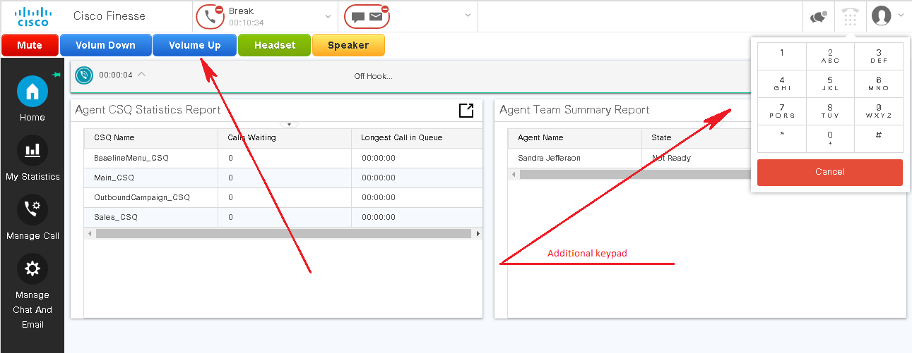
The gadget brings also ability to define additional action performed by gadget during or after the call for actions: Speaker (Key:Speaker) and Headset (Key:Headset). The Administrator can configure the following options:
- Transfer to Post Call Survey – ability to transfer the call to post call survey, when the call is active.
- Deactivate button at active call – makes the function button inactive when the agent has an active call

Contact information
If you enjoyed the content and you:
- Have an idea how it could be extended to improve the feature set of the gadget
- Found an error in the gadget code that requires a fix
- Found a bug/gap in the documentation
- Have a project where you stuck and need an assistance
Feel free to contact us. We will do our best to resolve any issues, add features to published solution.
Below the list of emails and places where you can find us.
Email addresses
General, Sales mailbox: (info@gaman-gt.com)
Support mailbox: (support@gaman-gt.com)

To find out more about Gaman Team and our project please visit our Website:
https://gaman-gt.com

Find us in social networks:
Linked In | Twitter | Upwork

